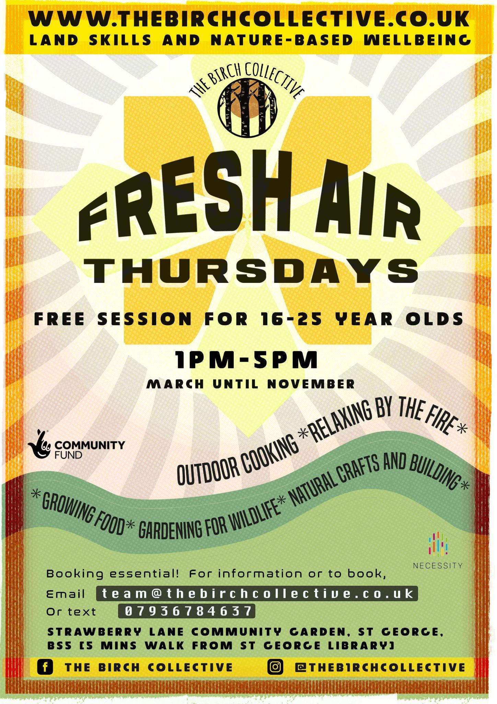

The Birch Collective run Fresh Air Thursdays (Thursdays 1-5pm), a free land skills and nature based wellbeing group for 16-25 year olds. These easy-going and supportive sessions offer a mix of practical, seasonal tasks, alongside relaxing and chatting by the fire. Fresh Air Thursdays are ideal for anyone who would benefit from spending some time outside in a beautiful place with other young adults and are keen to learn some new skills.

Activities include:
- Gardening and food growing for wildlife
- Natural building (pizza oven construction, building with green timber)
- Natural Craft (willow and clay work, whittling and wood carving)
- Fireside Cookery (learning to prepare, maintain and cook on open fires)
- Nature-based stress reduction techniques

Where:
Strawberry Lane Community Garden, St George

When:
Every Thursday 1-5pm from Thursday 30th March until November

Who for:
This group is ideal for anyone age 16-25 who:
- Would benefit from time spent outside with other young people
- Is struggling to engage with study or work
- Has mental or physical health struggles
- Is experiencing loneliness or isolation

What our participants say:
‘ I always feel more relaxed at the end of Fresh. It feels like anything is accepted- if you want to help out and learn things there’s always that and if you want to just be quiet and on your own that is also ok.’

‘Fresh gives me a reason to get out of the house and meet people- old and new faces.’
‘The Birch Collective offers a fantastic opportunity for our young people to continue building on confidence, communication and team building skills in numerous ways. Fresh Air Thursdays allows young people to branch out of their comfort zone and bond with other young people of a similar age; supporting in creating friendships whilst keeping attendance casual. It has been ideal for the young people we work with who have challenges with mental health, and that flexibility has been fantastic for them in building up their confidence on their terms.’ Rosie Kinnear | Youth Development Lead | The Prince's Trust

How do I sign up?

To refer anyone to Fresh or our steering group, you can either direct them to our website where they can register their interest to the programme here or if you would like to give us more detail about the potential participant you could fill in the interest form attached and send it to amy@thebirchcollective.co.uk. We will then get in touch directly with the participant to arrange a trial session.

If people would like, we can meet at the garden on a wednesday to see the site and chat about the session to see if it is something they would like to try out. Support workers are welcome to join them. They don’t need to make a commitment to coming to all the Thursday sessions and they can drop in when they can for as long as they can.

Any questions, please get in touch.

