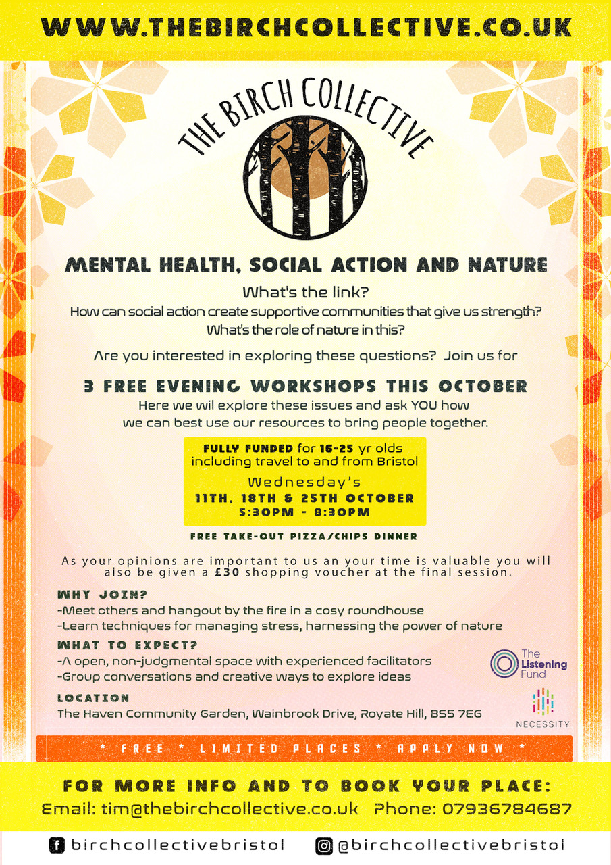
What to expect:
- Tell us what you’d like to see more of for your age group
- Chance to join our decision-making board, building employability skills.
- Opportunities for further training as ‘peer mentors’
- Practise new ways to communicate and solve problems with others
- Shape future plans of The Birch Collective
If you have any questions please get in touch on tim@thebirchcollective.co.uk
Booking essential! Please sign up here

