Quick apply application

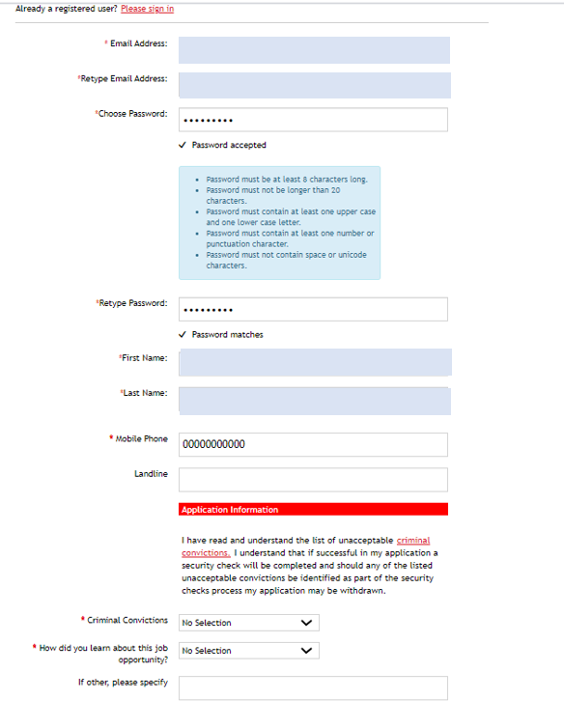

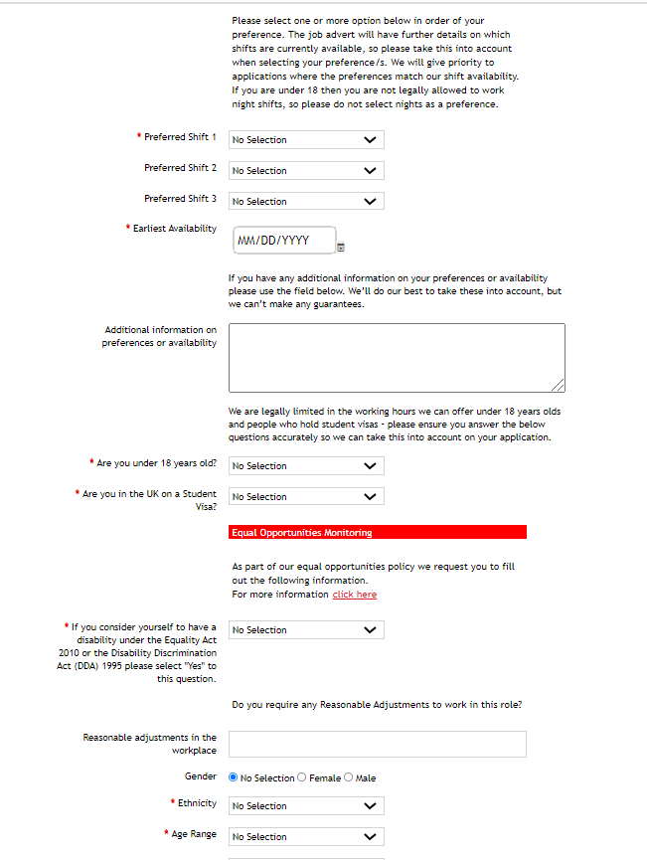

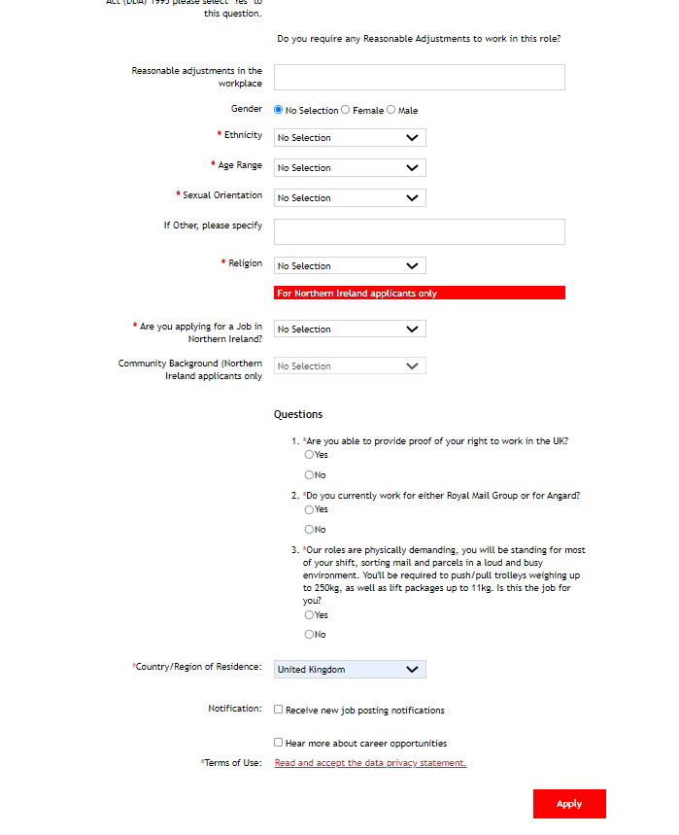

The three questions at the end of the application are crucial. If one is answered incorrectly, they will be automatically withdrawn. They must be able to provide proof of RTW, they must NOT be currently working for Royal Mail or Angard and they must be able to cope with the physical demands of the role. Reasonable adjustments can be made if they declare a reasonable adjustment.

Candidates have to click the ‘terms of use link’ and ‘accept’.

Once all information is complete and they click apply, they will receive an email straight away.