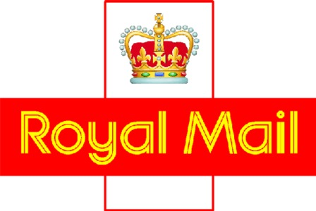

What offences are deemed as unacceptable to Royal Mail?
The following offences if ‘unspent’ are deemed as unsuitable to the business.
Please note: The list below is not exhaustive but instead is designed to give a clear indication of the nature of offences that Royal Mail Group Ltd deems as unacceptable.

- Arson

- Firearms/Weapons Offences (inc possessing a sharp object in public, noxious gas)

- Fraud, Forgery or Counterfeiting Offences (inc benefit deception, travelling on a train without paying)

- Terrorism (other than certain conflict-related offences subject to the Northern Ireland Good Friday Agreement – these do not need to be declared during application and will be considered by applying the employer’s guidance issued by the Office of the First Minister & Deputy First Minister, Northern Ireland)

- Possession of Category A drugs

- Supply / intent to supply any category of drugs

- Offences against the Justice System (inc bribery, contempt of court, making false statements, perjury)

- Offences against the Person (inc assault, causing grievous or actual bodily harm, battery, affray, racial and verbal harassment, making threats)

- Offences against the Postal Service and prior legislation

- Sexual Offences

- Theft and all offences of dishonest appropriation (inc going equipped to burgle, aggravated vehicle taking, obtaining stolen property, make off without paying)

- Breaches of orders

In addition for certain roles e.g. driving vacancies, the requirements may differ and for some roles may be determined by industry security standards. Please be aware that none of these examples are exhaustive and if unsure, advice should be sought prior to making any decisions based on these.
For further information please see the Rehabilitation of Offenders Act

